Generative AI
Prompt Engineering

By
Shumaila Maryam
Student ID: SU92-BSDSM-F24-062
Mehwsih
Student ID: SU92-BSDSM-F24-061

Project Proposal submitted to the
Under Graduate Centre for Data Science Superior University, Lahore

Course
Generative AI

Supervisor
Ma’am Laiba Tahir

1. Introduction
Computer vision is an active research area in medical-image analysis because deep-learning models can learn visual patterns from labelled images. In dermatology research, image classifiers have been investigated for distinguishing between categories of skin lesions. However, accuracy alone does not show whether a model can be trusted in an individual case. A model may produce a wrong class with high confidence, particularly when an image is unclear or differs from the examples used during training.
Glowra AI is proposed as a reliability-aware skin-lesion analysis prototype. Instead of always returning a class, the system will estimate whether a prediction is sufficiently reliable to present. The project will study probability calibration, uncertainty scores, and selective prediction. Selective prediction allows a model to return a class when a defined condition is met, or abstain when evidence is insufficient. This makes it possible to measure the relationship between the number of accepted predictions and the error rate among those predictions.
The project will use dermoscopic images from HAM10000. To keep the project manageable, the first version will focus on three labels: MEL, BCC, and BKL. These labels do not cover all skin conditions. The application will clearly state its supported classes and limitations, and it will not present its output as a confirmed medical diagnosis.

2. Problem Statement
Many image-classification systems display a predicted class and confidence score without explaining the limits of that confidence. A model can be confidently wrong, poorly calibrated, or exposed to an input that does not belong to any class represented in its training data. Systems that always return a label may hide these risks from users. In addition, an automatically generated explanation may contain claims that are not supported by evidence unless retrieval and citation quality are checked.
The problem addressed by Glowra AI is how to identify and communicate potentially unreliable predictions in a three-class skin-lesion research prototype. The project will test whether probability calibration and uncertainty-based abstention can reduce errors among accepted predictions. It will also investigate whether an optional evidence-grounded explanation module can provide traceable educational information without overstating what the classifier can establish.

3. Aim and Objectives

3.1 Aim
To design, implement, and evaluate a skin-lesion classification prototype that measures prediction uncertainty and can abstain from presenting unreliable classifications.

3.2 Objectives
- Prepare a reproducible three-class HAM10000 subset and document its class distribution and limitations.
- Train a transfer-learning baseline classifier and report class-wise and overall performance.
- Calibrate model probabilities using validation data and compare calibrated with uncalibrated confidence.
- Evaluate confidence-based and entropy-based scores for identifying incorrect predictions.
- Implement an abstention threshold selected on validation data and measure coverage-risk trade-offs.
- Use Grad-CAM to inspect selected correct and incorrect predictions.
- Develop an optional RAG-based educational explanation module using curated, traceable sources.
- Evaluate retrieval relevance, citation correctness, and unsupported claims separately from classifier performance.
- Build an interactive application that communicates uncertainty, limitations, and research-only intended use.

4. Research Questions
- RQ1: Does probability calibration improve the reliability of confidence scores compared with uncalibrated model outputs?
- RQ2: Can confidence or predictive entropy identify incorrect predictions?
- RQ3: How does abstention affect prediction coverage and the error rate among accepted predictions?
- RQ4: How does the uncertainty mechanism behave on low-quality images and defined out-of-distribution examples?
- RQ5: Does RAG with citation checking reduce unsupported educational claims compared with generation without retrieved evidence?

5. Proposed Innovation and Novelty
Transfer learning, calibration, uncertainty scoring, Grad-CAM, and RAG have each been explored in previous research. Therefore, this proposal does not claim that any one of these techniques is new. The proposed contribution is an integrated and measurable workflow that makes prediction reliability the primary evaluation target in a manageable undergraduate application.
- Error-aware evaluation: measure whether uncertainty scores rank incorrect predictions above correct ones, instead of reporting accuracy alone.
- Selective prediction: allow the application to abstain when a validation-selected reliability condition is not met.
- Transparent failure inspection: review errors using class-wise metrics and Grad-CAM, while treating visual explanations as inspection aids rather than proof of correctness.
- Evidence-grounded explanations: if the RAG module is completed, attach source references and evaluate citation correctness and unsupported claims.
The novelty claim will be refined after a focused literature review. The final report will describe the contribution supported by experiments and will not claim that the system is the first of its kind without evidence.

6. Scope and Limitations

6.1 Included in scope
- A three-class dermoscopic image classifier for MEL, BCC, and BKL.
- Image-file validation and basic input-quality checks.
- Transfer learning, probability calibration, uncertainty scoring, and selective prediction.
- An application dashboard for predictions, abstentions, and evaluation results.
- Grad-CAM visual inspection of selected cases.
- A small curated knowledge base and RAG explanation module, subject to project time and compute.
- A reproducible train/validation/test protocol with documented metrics.

6.2 Out of scope
- Clinical diagnosis, treatment recommendations, or emergency triage.
- Claims that the system analyses ordinary selfies, acne, eczema, psoriasis, or all skin diseases.
- Replacing a dermatologist or claiming clinical readiness based only on public-dataset performance.
- Guaranteeing that uncertainty scores will detect every incorrect or out-of-distribution image.
Dataset limitation: HAM10000 contains dermoscopic skin-lesion images, not ordinary face selfies. BKL is a grouped label for benign keratosis-like lesions rather than one single disease. The user interface and report must use these terms accurately.

7. Target Audience and Intended Use
The intended audience includes university students, machine-learning researchers, project evaluators, and educators interested in model reliability. The prototype will demonstrate how a prediction may be accepted, flagged as uncertain, or rejected because an input is unsuitable. It is not intended for patients to make health decisions, and its outputs must not be interpreted as a confirmed diagnosis.

8. Dataset and Data Preparation

8.1 Dataset
HAM10000 was introduced by Tschandl, Rosendahl, and Kittler (2018). It contains 10,015 dermoscopic images across seven diagnostic categories. The proposed project will use three classes to keep the experimental scope achievable.
Label | Category | Proposed starting count
MEL | Melanoma | 1,113
BCC | Basal cell carcinoma | 514
BKL | Benign keratosis-like lesions | 1,099
Total | Selected three-class subset | 2,726

These counts must be verified against the exact downloaded metadata before training. Final counts will be reported after checking missing files, duplicates, and exclusions.

8.2 Preparation protocol
- Download the dataset and metadata from a legitimate source and record the version or access date.
- Check image paths, labels, duplicates, unreadable files, and missing metadata.
- Create a reproducible manifest containing image IDs, lesion IDs where available, labels, and split assignments.
- Split by lesion identifier where metadata permits to reduce leakage between images of the same lesion; stratify as feasible.
- Use a proposed 70% training, 15% validation, and 15% test split, adjusted only if grouped stratification requires it.
- Apply augmentation to training images only and use consistent preprocessing for validation and test images.
- Use validation data for model selection, calibration, and threshold selection; keep the final test set untouched until evaluation.

9. Proposed Methodology

9.1 Baseline classifier
The initial model will use EfficientNet-B0 with transfer learning in PyTorch. Its final classification layer will be adapted to the three selected classes. A single baseline model is preferred over a large ensemble to keep the work interpretable and achievable at intermediate undergraduate level.

9.2 Input validation
Before inference, the application will verify that the file can be opened, uses an accepted image format, and has sufficient dimensions for processing. A basic blur or exposure check may be added if it can be validated. These checks do not guarantee clinical image suitability.

9.3 Probability calibration
The classifier's raw probabilities will be compared with calibrated probabilities. Temperature scaling will be fitted using validation data only. Calibration quality will be measured using Expected Calibration Error (ECE) and the Brier score, alongside predictive performance.

9.4 Uncertainty and abstention
Two initial uncertainty signals will be evaluated: maximum predicted class probability and predictive entropy. Thresholds will be selected on validation data according to a documented criterion. At inference, the system will either show a tentative class with an uncertainty statement or abstain and request further review. The test set will be used only to report the final coverage and error trade-off.

9.5 Grad-CAM inspection
Grad-CAM heatmaps will be generated for selected examples to inspect image regions that influence a prediction. The project will review both correct and incorrect cases. Heatmaps will not be described as proof that a prediction is correct or clinically explainable.

9.6 Evidence-grounded explanation module
If time permits, a retrieval-augmented generation module will retrieve relevant passages from a small curated set of reputable dermatology references. A language model will produce a plain-language educational summary based on those passages, with source details shown in the interface. The module will be evaluated for retrieval relevance, citation correctness, and unsupported claims. RAG will not be assumed to guarantee factual accuracy.

9.7 Application implementation
The working research prototype will include image upload, input validation, model inference, uncertainty/abstention display, a Grad-CAM view, a short explanation panel, and a research dashboard. A frontend-only interface can demonstrate navigation and simulated sample states, but genuine model evaluation requires model inference to run locally or through a connected service. The final implementation choice will be documented honestly.

10. Proposed System Architecture

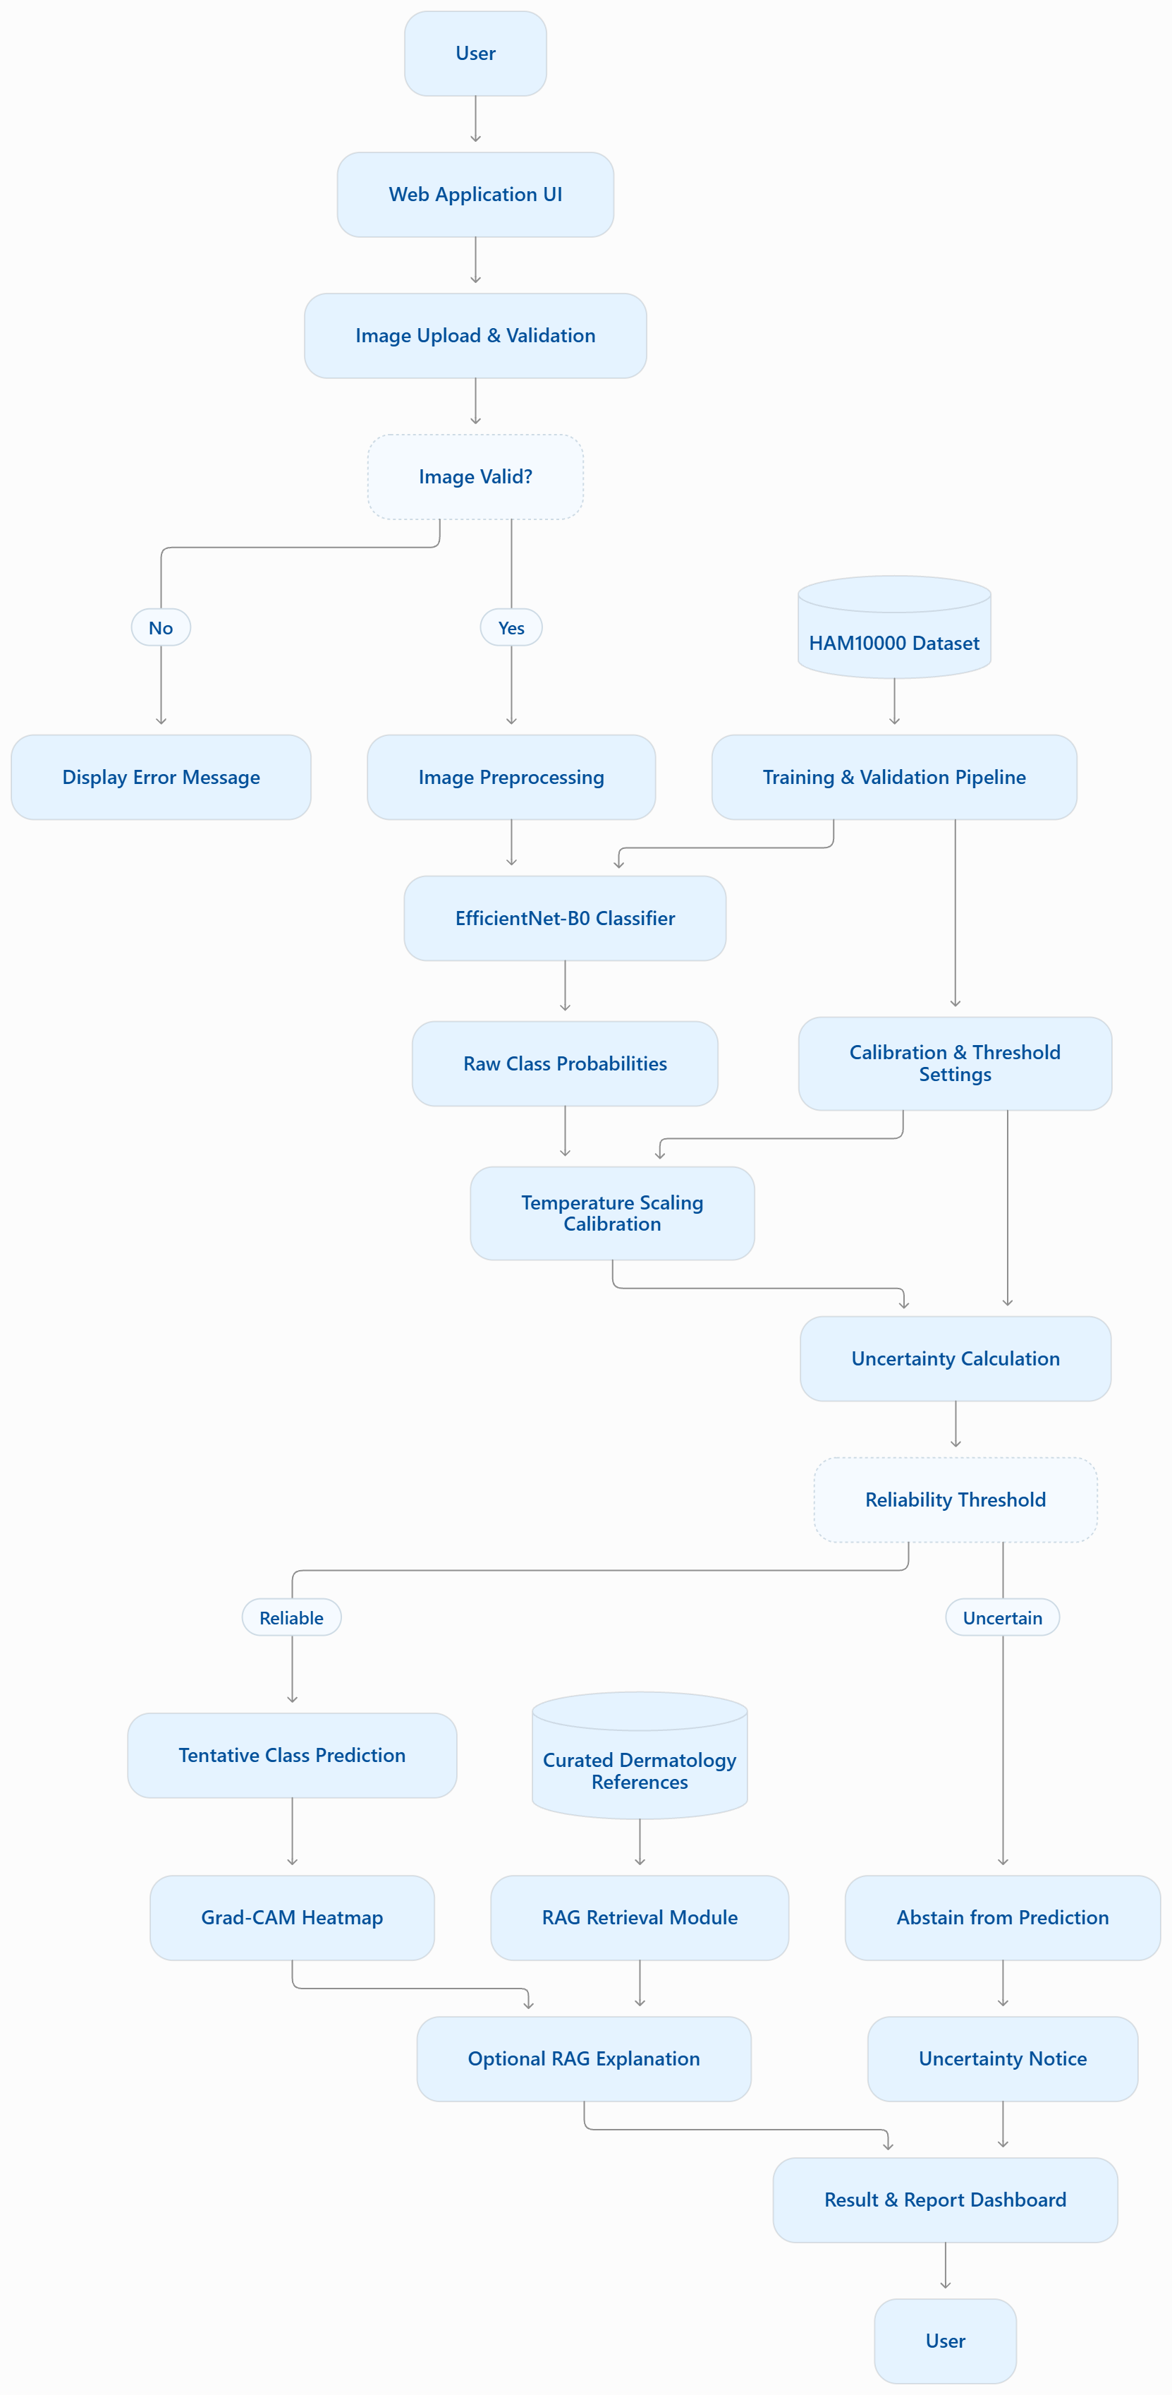

Stage | Component | Purpose
1 | User interface | Upload a dermoscopic image and display the supported classes and limitations.
2 | Input validation | Check file type, readability, dimensions, and optional quality indicators.
3 | Preprocessing | Resize and normalize the image using the model's training configuration.
4 | Classifier | Predict MEL, BCC, or BKL probabilities using the trained model.
5 | Calibration | Apply validation-fitted temperature scaling to improve probability reliability.
6 | Uncertainty gate | Accept a prediction or abstain according to a validation-selected rule.
7 | Explanation | Display Grad-CAM inspection output and optional RAG-grounded educational information.
8 | Result/report | Show class or abstention, uncertainty notice, source references, and limitations.

10.1 Workflow

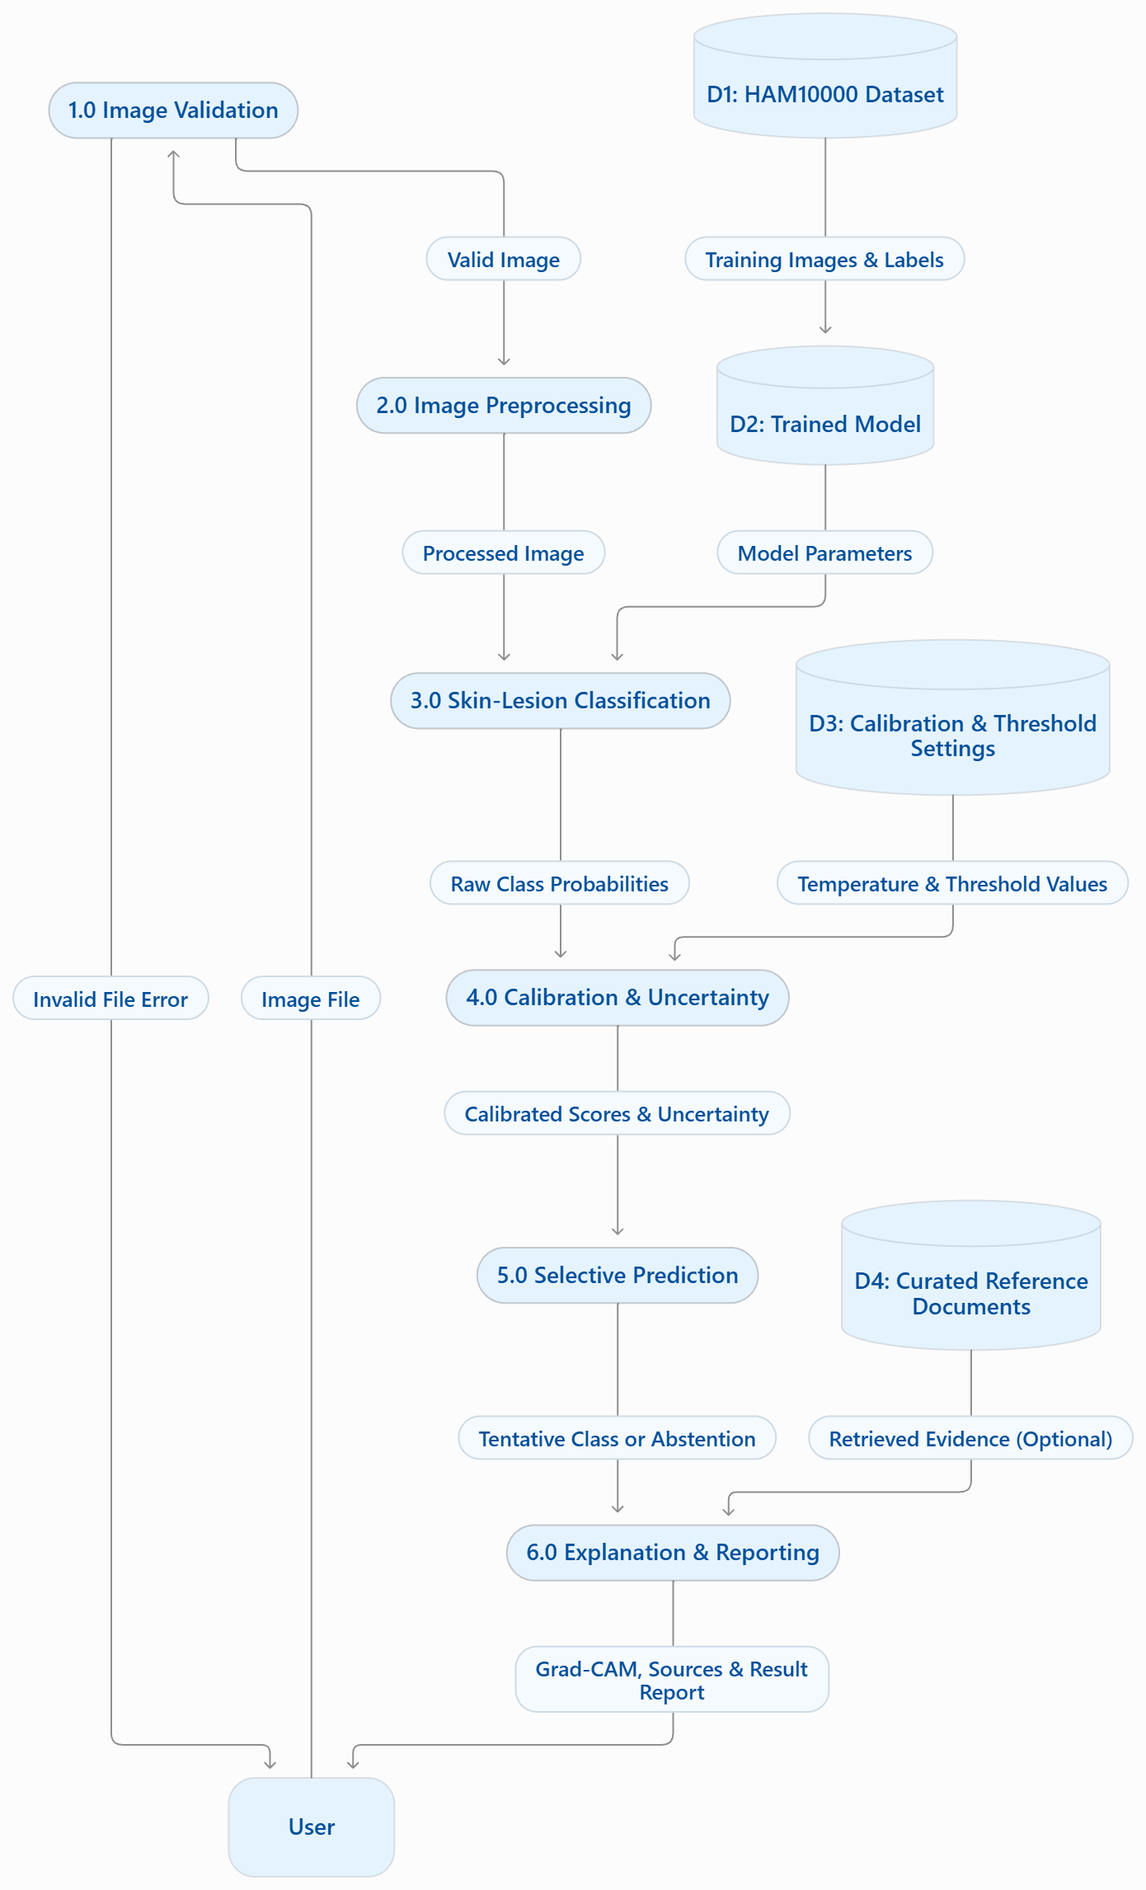

Step | Workflow action | Output
1 | User uploads a supported dermoscopic image | Image file
2 | Validate file and basic image properties | Accepted input or error message
3 | Preprocess image | Model-ready tensor
4 | Run classifier | Raw class probabilities
5 | Calibrate probabilities and calculate uncertainty | Calibrated scores and uncertainty signal
6 | Apply abstention rule | Tentative class or abstention
7 | Generate optional Grad-CAM and retrieve supporting text | Inspection heatmap and sourced educational content
8 | Display result with limitations | Transparent research output

11. Experimental Design
The experiments will compare the proposed components independently where possible. All model-selection and threshold decisions will be made using training and validation data. The final test set will be used once for the planned final evaluation.
Experiment | Comparison | Main evaluation
E1: Baseline | EfficientNet-B0 classifier | Macro-F1, per-class recall, confusion matrix, AUROC where applicable
E2: Calibration | Raw vs temperature-scaled probabilities | ECE, Brier score, calibration plots
E3: Selective prediction | Always predict vs abstain under selected threshold | Coverage-risk curve, accepted-case error rate, rejection rate
E4: Error detection | Maximum probability vs entropy | AUROC/AUPRC for identifying incorrect predictions
E5: Input shift | Supported test images vs defined unsuitable/OOD examples | Rejection behaviour and false acceptance rate
E6: Visual inspection | Correct vs incorrect cases with Grad-CAM | Qualitative review; no claim of clinical proof
E7: Explanation grounding | LLM-only vs RAG-supported generation, if implemented | Retrieval relevance, citation correctness, unsupported-claim rate

11.1 Evaluation metrics
- Macro-F1 and per-class precision, recall/sensitivity, and confusion matrix.
- AUROC for one-vs-rest classification where suitable; report class-wise results.
- Expected Calibration Error (ECE) and Brier score for probability reliability.
- Coverage-risk curves and error rate among accepted predictions for selective prediction.
- AUROC/AUPRC for detecting incorrect predictions from uncertainty scores.
- For optional RAG: retrieval relevance, citation correctness, and unsupported-claim rate.
No performance value is assumed in advance. The final report will include measured results, confidence intervals where feasible, and observed limitations.

12. Ethical Considerations and Risk Management
- The application will clearly state that it is a research prototype and not a medical diagnostic service.
- It will not recommend treatment or advise users to delay professional assessment.
- Dataset class imbalance and possible demographic or acquisition bias will be discussed.
- Images and outputs will be handled according to dataset licence terms and university requirements.
- Uncertain predictions will be labelled clearly; abstention will not be presented as a diagnosis.
- Any generated explanation will be labelled educational and accompanied by its retrieved sources where available.
- The report will avoid claiming general clinical performance from a single public dataset.

13. Proposed Modules
Module | Description
Dataset management | Load metadata, verify files, prepare split manifests, and record class counts.
Image preprocessing | Resize, normalize, and perform basic input validation.
Classification | Run the trained three-class transfer-learning model.
Calibration and uncertainty | Calibrate probabilities, compute uncertainty, and apply abstention.
Explainability | Generate Grad-CAM heatmaps for selected predictions.
Knowledge retrieval | Retrieve relevant passages from curated references for educational summaries, if implemented.
User interface | Upload image, show result/abstention, explain limitations, and display sources.
Evaluation dashboard | Show model metrics, calibration results, confusion matrix, and coverage-risk comparisons.

14. Deliverables
- A documented and reproducible dataset preparation pipeline.
- A trained baseline classifier and saved evaluation configuration.
- Calibration and uncertainty/abstention experiments.
- A working application prototype with transparent result states.
- A research dashboard and visualisations of the evaluation results.
- A final report containing methodology, results, limitations, and references.
- Optional RAG explanation module, if completed within the approved project timeline.

15. Proposed Timeline
Weeks | Activities | Expected output
1 | Literature review and project scope confirmation | Research questions and refined proposal
2 | Dataset download, audit, and split design | Clean manifest and data report
3–4 | Baseline model training and evaluation | Baseline metrics and confusion matrix
5 | Calibration, uncertainty scores, and abstention | Calibration plots and coverage-risk analysis
6 | Grad-CAM and optional RAG module | Visual inspection examples and/or sourced explanation prototype
7 | Application integration and testing | End-to-end prototype
8 | Final experiments, documentation, and presentation | Final report, demo, and presentation

16. Expected Outcomes
The expected outcome is a functional research prototype and an empirical report showing how calibration and uncertainty-based abstention affect the reliability of skin-lesion classification. The project is expected to provide a transparent comparison between always predicting and selectively abstaining, but no improvement is guaranteed before experiments are completed. The evaluation should reveal both strengths and failure cases, including cases where the uncertainty mechanism fails to flag an incorrect prediction.

17. Conclusion
Glowra AI proposes a focused undergraduate investigation into the reliability of skin-lesion image classification. Its main emphasis is not simply to maximise accuracy, but to study when predictions may be incorrect and how uncertainty should be communicated. A three-class HAM10000 subset, transfer learning, probability calibration, error detection, and selective prediction provide a manageable experimental foundation. Grad-CAM and an optional evidence-grounded explanation module can support inspection and educational transparency. The project will be successful as a research study if it implements a reproducible method and reports honest, measurable findings—including limitations—rather than assuming that the model is reliable or clinically ready.

References
- Tschandl, P., Rosendahl, C., & Kittler, H. (2018). The HAM10000 dataset, a large collection of multi-source dermatoscopic images of common pigmented skin lesions. Scientific Data, 5, 180161. https://doi.org/10.1038/sdata.2018.161
- Guo, C., Pleiss, G., Sun, Y., & Weinberger, K. Q. (2017). On Calibration of Modern Neural Networks. Proceedings of the 34th International Conference on Machine Learning, 70, 1321–1330.
- Selvaraju, R. R., Cogswell, M., Das, A., Vedantam, R., Parikh, D., & Batra, D. (2017). Grad-CAM: Visual Explanations from Deep Networks via Gradient-Based Localization. Proceedings of the IEEE International Conference on Computer Vision (ICCV), 618–626.
- Lewis, P., Perez, E., Piktus, A., et al. (2020). Retrieval-Augmented Generation for Knowledge-Intensive NLP Tasks. Advances in Neural Information Processing Systems, 33, 9459–9474.
- PyTorch. (n.d.). Transfer learning for computer vision tutorial. https://pytorch.org/tutorials/beginner/transfer_learning_tutorial.html

